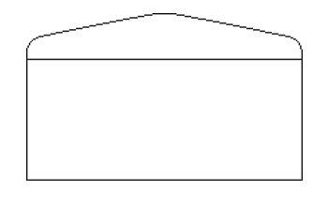
DIGITAL ENVELOPE BUDGET TRACKING
Starting Balance: $_________
Monthly Deposit: $_________
Extra Deposit: $_________
Total: $_________

Actual Cost: $_________
Amount Left: $________
Move to: _______________

Actual Cost: $_________
Amount Left: $________
Move to: _______________

Actual Cost: $_________
Amount Left: $________
Move to: _______________

Actual Cost: $_________
Amount Left: $________
Move to: _______________

Actual Cost: $_________
Amount Left: $________
Move to: _______________

Actual Cost: $_________
Amount Left: $________
Move to: _______________

$150
$50
$200
$50
$50
$75
$500
Savings
Internet
Misc.
Phone
Water
Electricity
Rent

